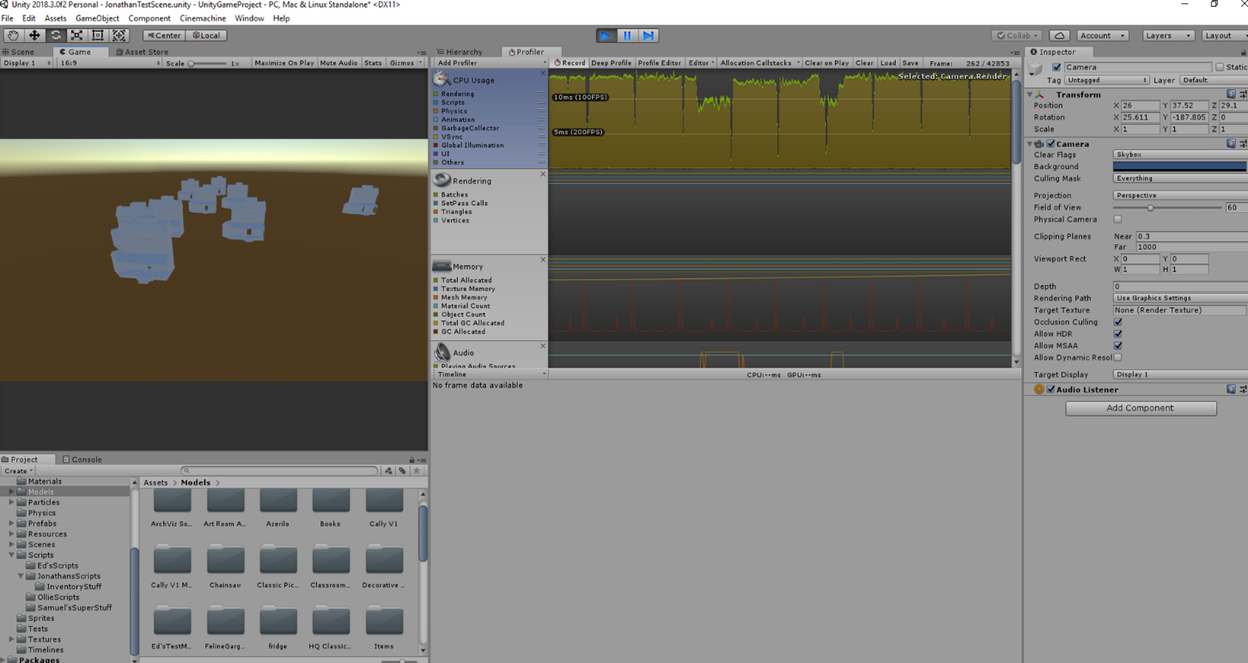Stress Testing – Outside house model

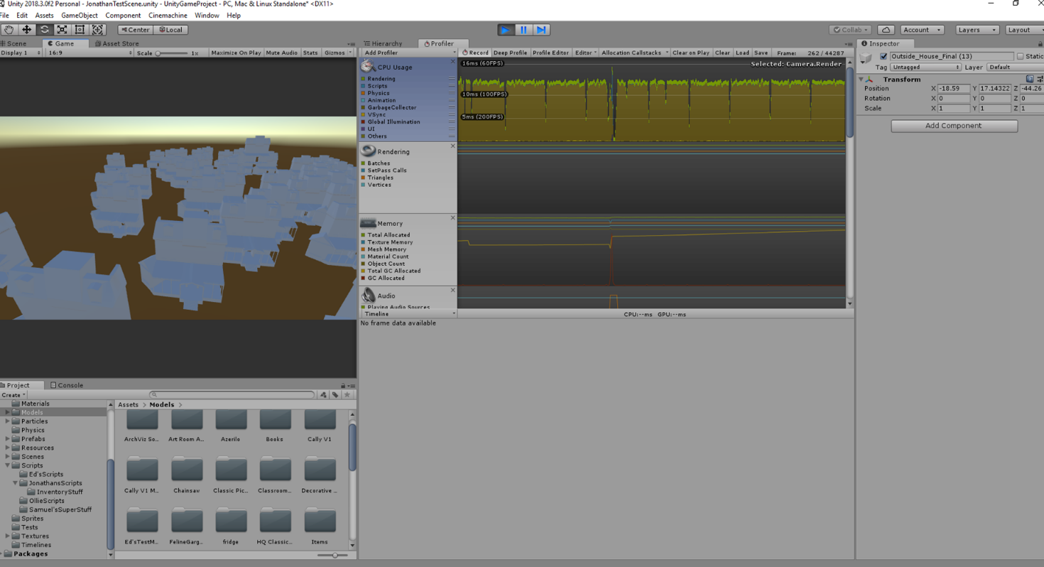Starting with 10 houses, the performance seems unaffected, upping to 50 next.

Moving up to 50 houses, the performance did dip a little but it was only momentarily. Moving up to 100.

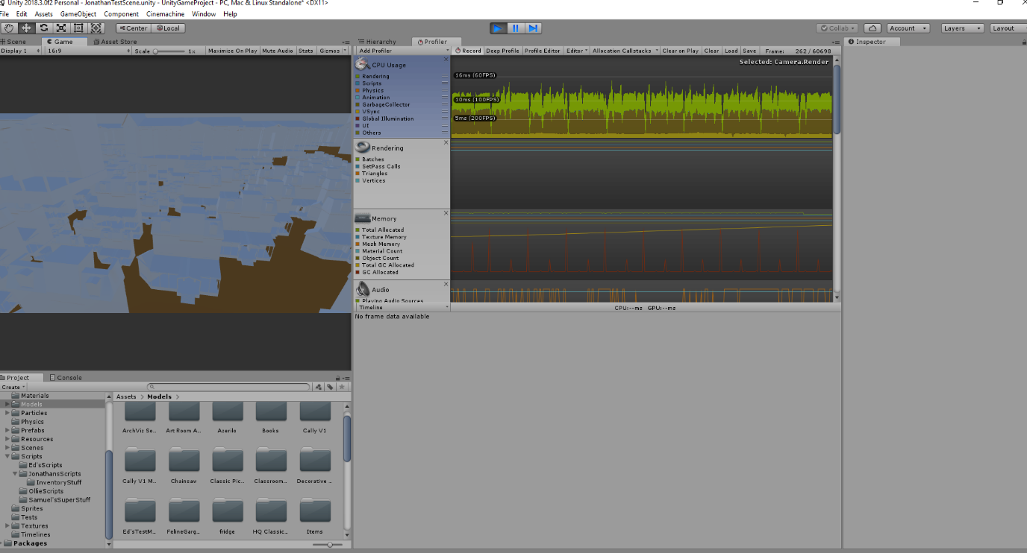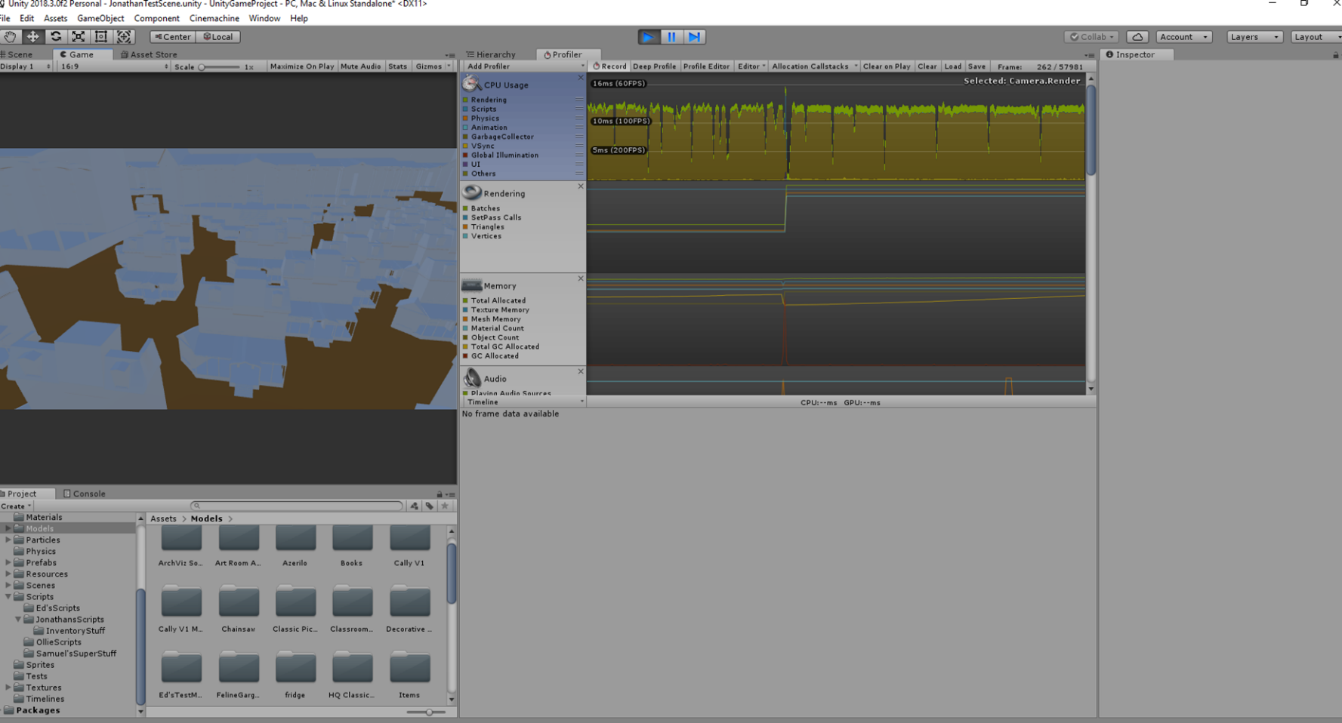With 100 houses, the dip at load is getting more noticeable, but it still runs smoothly. Next 1000

With 1000 houses the performance at the start really starts to tumble, though after a while it does recover. Lastly 5,000 houses!

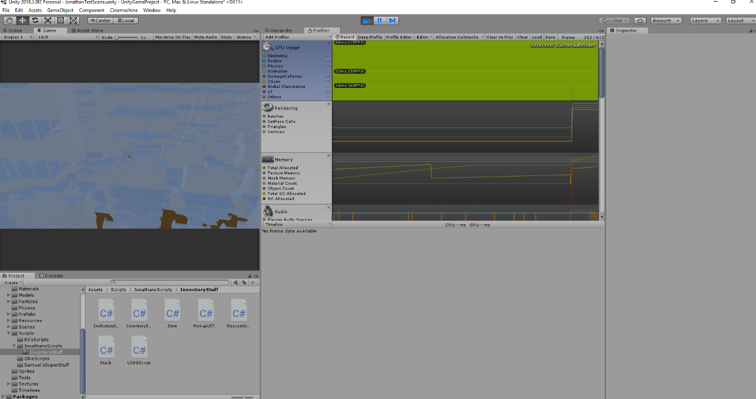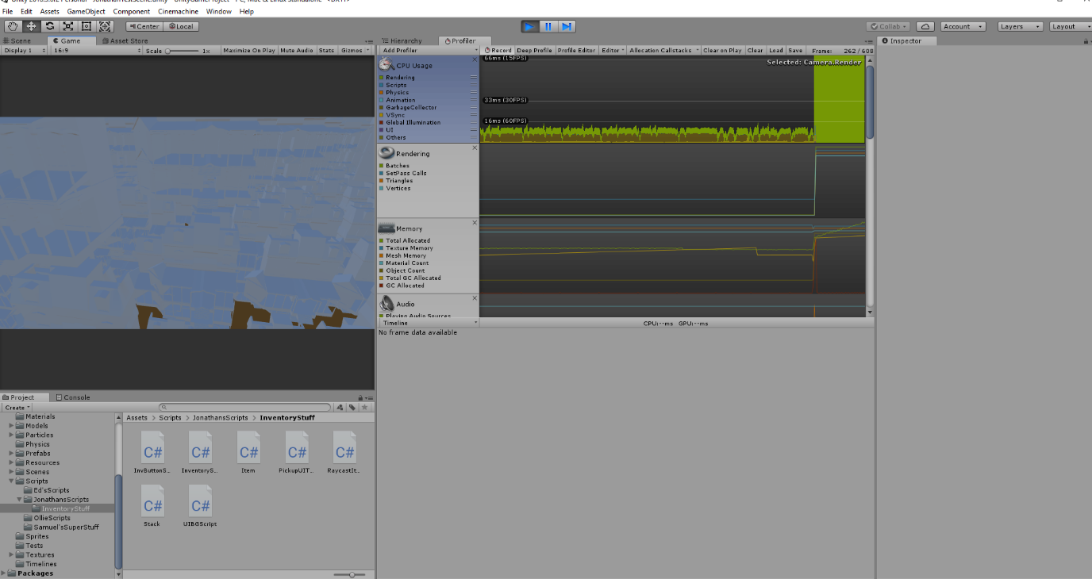With 5,000 houses the performance really hit the fan. Not stabilising for a long time and really using up the computers performance. Last test to see how bad the houses is 10,000 houses.

So, with 10,000 houses I think I’ve found the limit. The system was didn’t load the scene for a minute and the scene maxed out the system and didn’t drop for the same amount of time.